PIMPRI CHINCHWAD EDUCATION TRUST’S
PIMPRI CHINCHWAD COLLEGE OF ENINEERING
SECTOR NO. 26, PRADHIKARAN, NIGDI, PUNE-44


A PBL IV Project Report

on

“Visage AI”

Under the Guidance of

Prof. Swati Jagtap

DEPARTMENT OF ELECTRONICS AND TELECOMMUNICATION

S.Y. (E&TC) 2022-23

CERTIFICATE

PIMPRI CHINCHWAD EDUCATION TRUST’S
PIMPRI CHINCHWAD COLLEGE OF ENINEERING
SECTOR NO. 26, PRADHIKARAN, NIGDI, PUNE-44



This is to certify that the project entitled “VISAGE AI” submitted by TEAM GENESIS Div A, Department of Electronics and Telecommunication, for the fulfillment of the PBL IV of S.Y (EnTC), has successfully completed their project work.

Guide Name | Dr. M. T. Kolte
Prof.Swati Jagtap | HOD (E&TC)

DEPARTMENT OF ELECTRONICS AND TELECOMMUNICATION
B.TECH

PIMPRI CHINCHWAD EDUCATION TRUST’S
PIMPRI CHINCHWAD COLLEGE OF ENINEERING
SECTOR NO. 26, PRADHIKARAN, NIGDI, PUNE-44

Details of Group Members
PRN No. | Class | Div | Name of Student | Mobile Number | Email Id
121B1E039 | S.Y | A | Khulpe Akash Rajendra | +91 70584 27229 | akash.khulpe21@pccoepune.org
121B1E040 | S.Y | A | Deshpande Parth Ajit | +91 8767419076 | parth.deshpande21@pccoepune.org
121B1E041 | S.Y | A | Kumar Parimal | +91 87099 13051 | parimal.kumar21@pccoepune.org
121B1E045 | S.Y | A | Dwivedi Gaurav | +91 9373947991 | gaurav.dwivedi21@pccoepune.org
121B1E046 | S.Y | A | Doiphode Rutuja Pritam | +91 87099 13051 | rutuja.doiphode21@pccoepune.org
121B1E047 | S.Y | A | Kumbhar Sagar Gowardhan | +91 84593 43663 | sagar.kumbhar21@pccoepune.org
121B1E050 | S.Y | A | Edle Devang Rajesh | +91 80805 82715 | devang.edle21@pccoepune.org
121B1E051 | S.Y | A | Gadling Dipanshu Rajendra | +91 79727 19298 | dipanshu.gadling21@pccoepune.org
121B1E056 | S.Y | A | Gavhane Anuj Krishnat | +91 77091 94298 | anuj.gavhane21@pccoepune.org

ABSTRACT

Face is the representation of one’s identity. Hence, we have proposed an automated student attendance system based on face recognition. Face recognition system is very useful in life applications especially in security control systems. The airport protection system uses face recognition to identify suspects and FBI (Federal Bureau of Investigation) uses face recognition for criminal investigations. In our proposed approach, firstly, video framing is performed by activating the camera through a user- friendly interface. The face ROI is detected and segmented from the video frame by using Viola-Jones algorithm. In the pre-processing stage, scaling of the size of images is performed, if necessary, in order to prevent loss of information. The median filtering is applied to remove noise followed by conversion of colour images to grayscale images. After that, contrast-limited adaptive histogram equalization (CLAHE) is implemented on images to enhance the contrast of images. In face recognition stage, enhanced local binary pattern (LBP) and principal component analysis (PCA) is applied correspondingly in order to extract the features from facial images. In our proposed approach, the enhanced local binary pattern outperform the original LBP by reducing the illumination effect and increasing the recognition rate. Next, the features extracted from the test images are compared with the features extracted from the training images. The facial images are then classified and recognized based on the best result obtained from the combination of algorithm, enhanced LBP and PCA. Finally, the attendance of the recognized student will be marked and saved in the excel file. The student who is not registered will also be able to register on the spot and notification will be given if students sign in more than once. The average accuracy of recognition is 100 % for good quality images, 94.12 % of low-quality images and 95.76 % for Yale face database when two images per person are trained.

ACKNOWLEDGEMENT

We express our sincere thanks to our guide Prof. Swati Jagtap who has guided our project during the entire project session. Her evaluation and invaluable suggestions have helped us tremendously toward the development of this project.
We are thankful to our honorable Dr.M.T. Kolte for providing us all the necessary resources and for his precious cooperation. We express our sincere gratitude to all teaching and non-teaching staff members for their valuable efforts.
At the end, expressing our heartfelt appreciation to our fellow members and colleagues to assist in the development of this project.

Akash Khuple (SYETA39)
Parth Deshpande (SYETA40)
Parimal Kumar (SYETA41)
Gaurav Dwivedi (SYETA45)
Rutuja Doiphode (SYETA46)
Sagar Kumbhar (SYETA47)
Devang Edle (SYETA50)
Dipanshu Gadling (SYETA51)
Anuj Gavhane (SYETA56)

CONTENTS

Chapter 1 Introduction
1. Introduction…………………………………………………….……..……..1
1.1 Background...................................................................................................1
1.2 Motivation……………….………................................................................1
1.3 Problem Statement………………………………………………………….2
1.4 Objective………...………………………………………………………….3

Chapter 2 Literature Survey……………………………………………………………...…5

Chapter 3 Methodology

3.1 Block Diagram ……………….…………...………………...……………..8
3.2 Proposed Techniques or methods
3.3 Elements Of Block Diagram……………...…….……..………....………..10
3.4 Block Diagram Explanation……………...…….…………..…….……......12

Chapter 4 Hardware and Software Implementation……………………………………….12

Chapter 5 Testing & Troubleshooting
5.1 Testing strategies & Test Procedures….………………….…….................13
5.2 Result………………………………………………………..………..........14

Chapter 6 Advantages & Applications
6.1 Advantages……………………………………………………………......16
6.1 Disadvantages……………………………………………………………..16
6.2 Applications…………………………...………....………….………….....17

Chapter 7 Conclusion…………………………………………...……….……………......18

References ……………………….……………………………………………....…….....19

CHAPTER 1

Introduction

1.1 Introduction

In the realm of computer vision and biometric identification, face detection and face recognition have emerged as vital technologies that play a significant role in various applications, ranging from security systems to personalized user experiences. The ability to detect and recognize faces accurately has become an essential component in modern society, revolutionizing fields such as surveillance, human-computer interaction, law enforcement, and social media.

The purpose of this project report is to explore the intricacies of face detection and face recognition techniques, along with their underlying algorithms and technologies. By examining the current state-of-the-art methods, we aim to provide a comprehensive overview of the advancements made in this field and their practical implications. Additionally, we will discuss the challenges faced by researchers and engineers, as well as potential future directions for further improvements.

The main objective of this project is to develop face recognition based automated student attendance system. In order to achieve better performance, the test images and training images of this proposed approach are limited to frontal and upright facial images that consist of a single face only. The test images and training images have to be captured by using the same device to ensure no quality difference. In addition, the students have to register in the database to be recognized. The enrolment can be done on the spot through the user-friendly interface.

1

1.2 Background

Face recognition is crucial in daily life in order to identify family, friends or someone we are familiar with. We might not perceive that several steps have actually taken in order to identify human faces. Human intelligence allows us to receive information and interpret the information in the recognition process. We receive information through the image projected into our eyes, by specifically retina in the form of light. Light is a form of electromagnetic waves which are radiated from a source onto an object and projected to human vision. Robinson-Riegler, G., & Robinson-Riegler, B. (2008) mentioned that after visual processing done by the human visual system, we actually classify shape, size, contour and the texture of the object in order to analyse the information. The analysed information will be compared to other representations of objects or face that exist in our memory to recognize. In fact, it is a hard challenge to build an automated system to have the same capability as a human to recognize faces. However, we need large memory to recognize different faces, for example, in the Universities, there are a lot of students with different race and gender, it is impossible to remember every face of the individual without making mistakes. In order to overcome human limitations, computers with almost limitless memory, high processing speed and power are used in face recognition systems.

The human face is a unique representation of individual identity. Thus, face recognition is defined as a biometric method in which identification of an individual is performed by comparing real-time capture image with stored images in the database of that person (Margaret Rouse, 2012).

Nowadays, face recognition system is prevalent due to its simplicity and awesome performance. For instance, airport protection systems and FBI use face recognition for criminal investigations by tracking suspects, missing children and drug activities (Robert Silk, 2017). Apart from that, Facebook which is a popular social networking website implement face recognition to allow the users to tag their friends in the photo for entertainment purposes (Sidney Fussell, 2018). Furthermore, Intel Company allows the users to use face recognition to get access to their online account (Reichert, C., 2017). Apple allows the users to unlock their mobile phone, iPhone X by using face recognition (deAgonia, M., 2017).

2

The work on face recognition began in 1960. Woody Bledsoe, Helen Chan Wolf and Charles Bisson had introduced a system which required the administrator to locate eyes, ears, nose and mouth from images. The distance and ratios between the located features and the common reference points are then calculated and compared. The studies are further enhanced by Goldstein, Harmon, and Lesk in 1970 by using other features such as hair colour and lip thickness to automate the recognition. In 1988, Kirby and Sirovich first suggested principle component analysis (PCA) to solve face recognition problem. Many studies on face recognition were then conducted continuously until today (Ashley DuVal, 2012)

  - Motivation
The motivation behind undertaking a project report on the topic of "Face Detection and Face Recognition" stems from the immense impact these technologies have had on various aspects of our lives. The ability to detect and recognize faces accurately has transformed numerous industries and opened up new possibilities for enhancing security, improving user experiences, and advancing human-computer interaction. The following factors highlight the significance and motivation for exploring this topic in depth:

Advancements in Computer Vision: With the rapid advancements in computer vision and machine learning, face detection and recognition have witnessed substantial progress. The development of sophisticated algorithms and the availability of large-scale datasets have significantly improved the accuracy and robustness of these technologies. Understanding the underlying methodologies and the progress made in face detection and recognition is crucial for staying updated with the latest advancements in computer vision.

Security and Surveillance: Face detection and recognition play a vital role in security and surveillance systems. These technologies enable efficient identification of individuals, enhancing access control, public safety, and law enforcement efforts. By investigating the techniques employed in face detection and recognition, we can contribute to the development of more accurate and reliable systems that aid in ensuring public safety.
Human-Computer Interaction: Face detection and recognition have revolutionized human-computer interaction. The ability to interpret and respond to facial expressions and gestures opens up new avenues for natural and intuitive user interfaces. By understanding the intricacies of these technologies, we can contribute to the development of user-friendly applications, immersive gaming experiences, and augmented reality interfaces.

3

Social Media and Personalization: The widespread adoption of social media platforms and photo-sharing applications has fueled the popularity of face detection and recognition. These technologies facilitate automatic tagging of individuals, content recommendations, and personalized experiences. Exploring the techniques and challenges in face detection and recognition allows us to gain insights into the mechanisms that power these platforms and contribute to their improvement.

Ethical Considerations: The increasing use of face detection and recognition technologies raises ethical concerns regarding privacy, data security, and potential biases. By delving into these topics, we can shed light on the ethical considerations associated with these technologies and contribute to the development of responsible practices, regulations, and safeguards. It is important to address these concerns to ensure the equitable and responsible deployment of face detection and recognition systems.

Future Applications and Innovation: The field of face detection and recognition is continuously evolving. New techniques, algorithms, and applications are being explored to address existing challenges and unlock the full potential of these technologies. By researching and reporting on the current state-of-the-art and future directions, we can contribute to the ongoing innovation and inspire further research and development in this field.

4

CHAPTER 2

Literature Survey

Review of Literature

Face detection and face recognition technologies have garnered significant attention in recent years, resulting in a vast body of research literature. This review aims to highlight key studies and contributions in the field of face detection and recognition, providing a comprehensive understanding of the advancements made in methodologies, algorithms, and applications.

Viola-Jones Algorithm for Face Detection:
Viola and Jones introduced a landmark algorithm in 2001 for real-time face detection. Their approach utilized Haar-like features and AdaBoost to create a strong classifier capable of detecting faces with high accuracy. This work laid the foundation for subsequent research in face detection and served as a benchmark for evaluating new algorithms.

Histogram of Oriented Gradients (HOG) for Face Detection:
Dalal and Triggs proposed the HOG algorithm for pedestrian detection in 2005, which was later adapted for face detection. HOG extracts local gradient information from an image to generate robust features for object detection. HOG-based face detectors achieved significant success and inspired further research in feature-based approaches.

Convolutional Neural Networks (CNNs) for Face Detection:
The advent of deep learning revolutionized the field of computer vision, including face detection. Researchers introduced CNN-based architectures such as Multi-task Cascaded Convolutional Networks (MTCNN) and Single Shot MultiBox Detector (SSD) for accurate and efficient face detection. These deep learning models achieved superior performance, handling complex scenarios and achieving real-time detection speeds.

5

Eigenfaces and Fisherfaces for Face Recognition:
Eigenfaces, proposed by Turk and Pentland in 1991, employed Principal Component Analysis (PCA) to extract facial features for face recognition. Later, Fisherfaces, introduced by Belhumeur et al., improved recognition accuracy by incorporating discriminant analysis. These linear subspace methods laid the foundation for subsequent advancements in face recognition algorithms.

Deep Learning Approaches for Face Recognition:
Deep learning models have significantly advanced face recognition performance. The DeepFace model, developed by Facebook AI Research, employed a deep convolutional neural network to achieve impressive accuracy on large-scale face recognition tasks. FaceNet and ArcFace introduced triplet loss and angular margin-based loss functions, respectively, improving face recognition robustness and discriminative power.

Dataset Bias and Fairness in Face Recognition:
Studies have highlighted the biases present in face recognition datasets, leading to fairness and accuracy issues, particularly for underrepresented demographic groups. Research efforts have been directed towards developing unbiased datasets, mitigating bias in training algorithms, and addressing the ethical implications of biased face recognition systems.

Applications of Face Detection and Recognition:
Face detection and recognition technologies find applications in diverse domains. In security and surveillance, these technologies enhance access control systems, public safety, and law enforcement efforts. They also facilitate natural and intuitive human-computer interaction, personalized experiences, and content recommendations in areas such as gaming, virtual reality, and social media.

Ethical Considerations and Privacy Concerns:
The widespread adoption of face detection and recognition raises ethical concerns regarding privacy, data security, and potential misuse. Researchers have emphasized the importance of responsible development practices, regulations, and safeguards to ensure the fair and responsible deployment of these technologies while protecting individuals' rights and privacy
6

The literature review demonstrates the evolution of face detection and recognition techniques, from traditional approaches to deep learning-based models. It highlights the challenges faced in achieving accurate detection and recognition under various conditions and emphasizes the need for ethical considerations and responsible deployment. The reviewed studies lay the groundwork for further research and development in this field, aiming to improve performance, address biases, and explore novel applications.
2.2 Preprocessing

Gaurav Dwivedi suggested cropping of detected face and colour image was converted to grayscale for pre-processing. They also proposed affine transform to be applied to align the facial image based on coordinates in middle of the eyes and scaling of image to be performed.

Pre-processing enhances the performance of the system. It plays an essential role to improve the accuracy of face recognition. Scaling is one of the important pre- processing steps to manipulate the size of the image. Scaling down of an image increases the processing speed by reducing the system computations since the number of pixels are reduced.

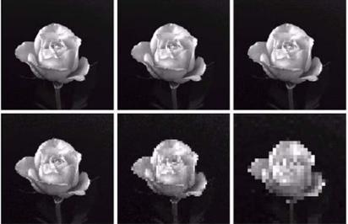

Besides scaling of images, colour image is usually converted to grayscale image for pre-processing. Grayscale images are believed to be less sensitive to illumination condition and take less computational time. Grayscale image is 8 bit image which the pixel range from 0 to 255 whereas colour image is 24 bit image which pixel can have 16 77 7216 values. Hence, colour image requires more storage space and more computational power compared to grayscale images. (Kanan and Cottrell, 2012). If colour image is not necessary in computation, then it is considered as noise. In addition, pre-processing is important to enhance the contrast of images. In the paper of Pratiksha M. Patel (2016), he mentioned that Histogram equalization is one of the methods of pre-processing in order to improve the contrast of the image. It provides uniform distribution of intensities over the intensity level axis, which is able to reduce uneven illumination effect at the same time.
7

2.2 Feature Extraction

The feature is a set of data that represents the information in an image. Extraction of facial feature is most essential for face recognition. However, selection of features could be an arduous task. Feature extraction algorithm has to be consistent and stable over a variety of changes in order to give high accuracy result.

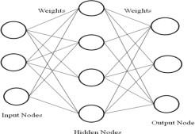

Convolutional Neural Network (CNN) is another neural network algorithm for face recognition. Similar to ANN, CNN consists of the input layer, hidden layer and output layer. Hidden layers of a CNN consists of multiple layers which are convolutional layers, pooling layers, fully connected layers and normalization layers. However, a thousand or millions of facial images have to be trained for CNN to work accurately and it takes long time to train, for instance Deepface which is introduced by Facebook

8

CHAPTER 3

Methodology

Block Diagram

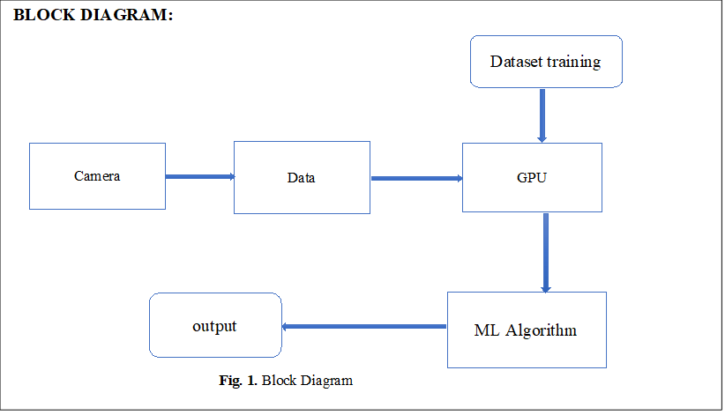

Explanation: -

- Camera will provide all the input for the system.
- The data will be acquired by camera in the form of images.
- Computer will perform feature extraction method on images.
- Pre trained model will take in all data from the computer.
- All the output we will receive predictions made by the model.

3.1 Input Images
Although our own database should be used to design real time face recognition student attendance system, the databases that are provided by the previous researchers are also used to design the system more effectively, efficiently and for evaluation purposes.

Yale face database is used as both training set and testing set to evaluate the performance. Yale face database contains one hundred and sixty-five grayscale images of fifteen individuals. There are eleven images per individual; each image of the individual is in different condition. The conditions included centre-light, with glasses, happy, left-light, without glasses, normal, right-light, sad, sleepy, surprised and wink. These different variations provided by the database is able to ensure the system to be operated consistently in variety of situations and conditions.

For our own database, the images of students are captured by using laptop built in camera and mobile phone camera. Each student provided four images, two for training set and two for testing set. The images captured by using laptop built in camera are categorized as low quality images, whereas mobile phone camera captured images are categorized as high quality image

3.2.1 Limitations of the Images

The input image for the proposed approach has to be frontal, upright and only a single face. Although the system is designed to be able to recognize the student with glasses and without glasses, student should provide both facial images with and without glasses to be trained to increase the accuracy to be recognized without glasses. The training image and testing image should be captured by using the same device to avoid quality difference. The students have to register in order to be recognized. The enrolment can be done on the spot through the user-friendly interface.
These conditions have to be satisfied to ensure that the proposed approach can perform well.

3.3.1 Pre-Processing

Testing set and training set images are captured using a camera. There are unwanted noise and uneven lighting exists in the images. Therefore, several pre-processing steps are necessary before proceeding to feature extraction.
Pre-processing steps that would be carried out include scaling of image, median filtering, conversion of color images to grayscale images and adaptive histogram equalization. The details of these steps would be discussed in the later sections.

9

Proposed Techniques or methods to be implemented:

- Data collection (we will be collecting high-definition face images of students).
- After collection of data all the images will be labelled and stored in folders with their respective names. Then we will reprocess the images before feeding to the model.
- We have chosen face net for recognition of faces (why did we chose face net) and we will train the model from the collected dataset on TensorFlow framework.
- The results/predictions made by the model will be collected in excel sheet by using pandas.

3.3 Flowchart

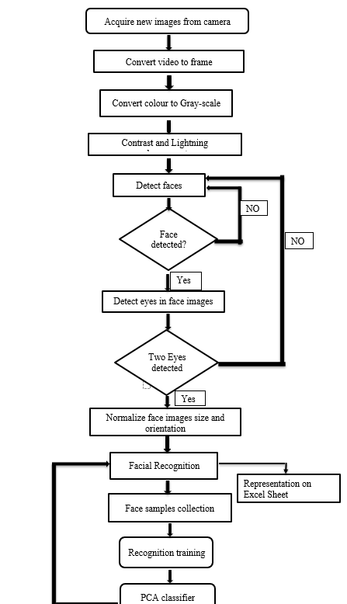

10
3.4 Explanation of Flowchart: -

- In the first step, image is captured from the camera. There is illumination effect in the captured images because of different lighting conditions and some noise which is to be removed in next step.
- Image is acquired from the camera that is connect above the board.
- Colour image is converted to gray scale image for increasing contrast.
- Then we will detect the faces by marking the rectangle on the faces of the student.
- After detection of faces we will detect the eyes.
- After the detection of faces from the next step is cropping of each detected face.
- Initially face detection algorithm tested on variety of images algorithm was applied to detect face in real time video.
- After the face detection next step is face recognition, this can be done by cropping the detected face and compare with the database. In this way face of student. Verified one
- by one and attendance is marked on the computer screen.

11

CHAPTER 4

Hardware and Software Requirements

Equipment:

1)CCTV camera (Resolution: 3MP, Quality: 1080, Wide angel camera)
2)Connecting cables
3)GPU

Facilities required (include software, hardware):

4.3 Communication, Budget etc.:

Sr No. | Equipment | Quantity | Price
1. | CCTV camera | 1 | Rs.1675.0/-
2. | TUL Corporation 1M1-M000127DVB Development Board PYNQ-Z2 Basic Kit Zynq SoC Xilinx | 1 | Rs.25,000.0/-
 |  |  | Total:- Rs.26,675/-

12

CHAPTER 5

Testing Results and Discussion

5.1 Observation Table

A) Observation Table using only already fetched in faces.

Input Faces | Detected faces(%) | Recognized Faces(%) | Unable to recognize(%)
10 | 100 | 100 | 0
10 | 100 | 90 | 10
10 | 100 | 100 | 0
10 | 100 | 60 | 40
10 | 100 | 90 | 10
10 | 100 | 100 | 0
10 | 100 | 100 | 0
10 | 100 | 100 | 0
10 | 100 | 66.67 | 33.33
10 | 100 | 90 | 10

B) Observation Table with unfetched faces .
Input Faces | Unknown/Untrained Faces | Detected Faces(%) | Correctly Recognized Faces(%) | Unable to recognize(%)
7 | 1 | 100 | 100 | 0
14 | 4 | 92.85 | 92.31 | 7.692
8 | 4 | 100 | 87.5 | 12.5
9 | 2 | 100 | 77.78 | 22.22
8 | 1 | 100 | 100 | 0

Result and Discussions

5.2 Result

In this proposed approach, face recognition student attendance system with user- friendly interface is designed by using MATLAB GUI(Graphic User Interface). A few buttons are designed in the interface, each provides specific function, for example, start button is to initialize the camera and to perform face recognition automatically according to the face detected, register button allows enrolment or registrations of students and update button is to train the latest images that have been registered in the database. Lastly, browse button and recognize button is to browse facial images from selected database and recognized the selected image to test the functionality of the system respectively.

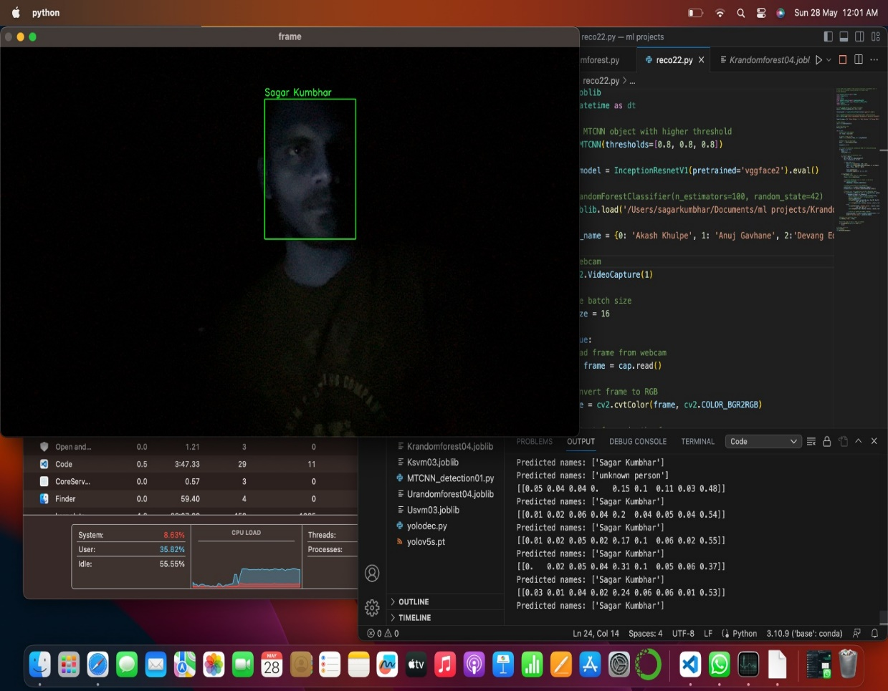
Results in dark environment (1)

13
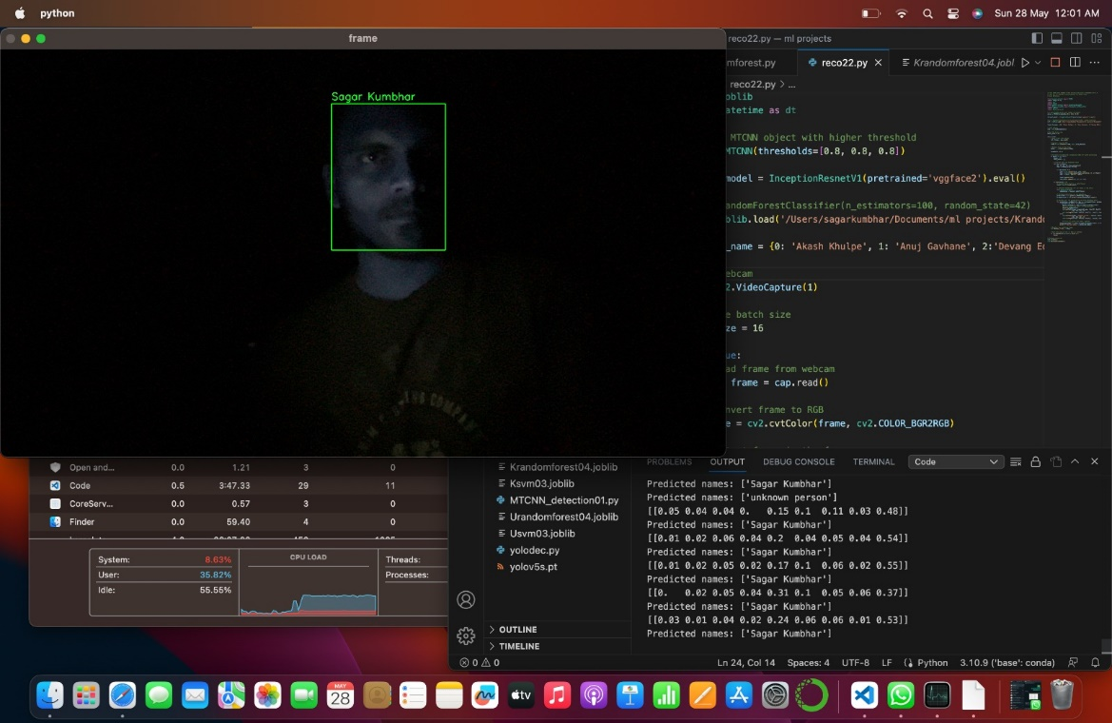
Results in dark environment (2)

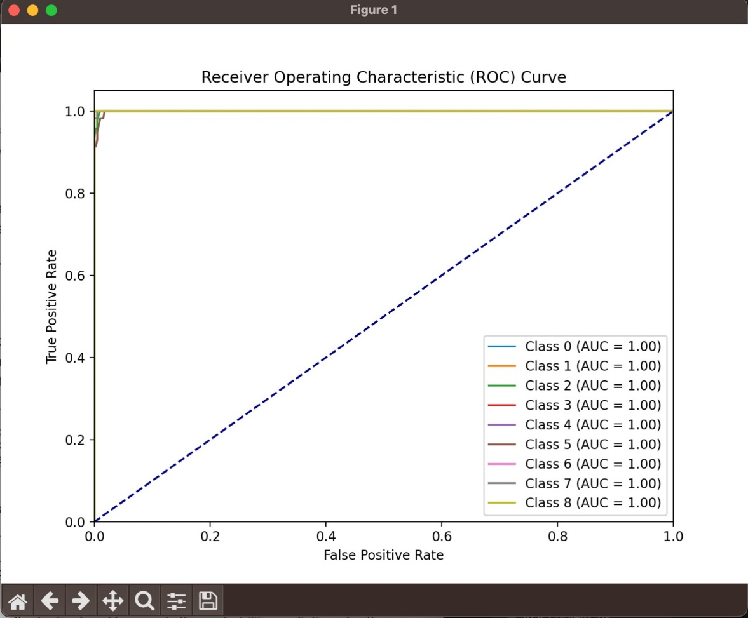

14
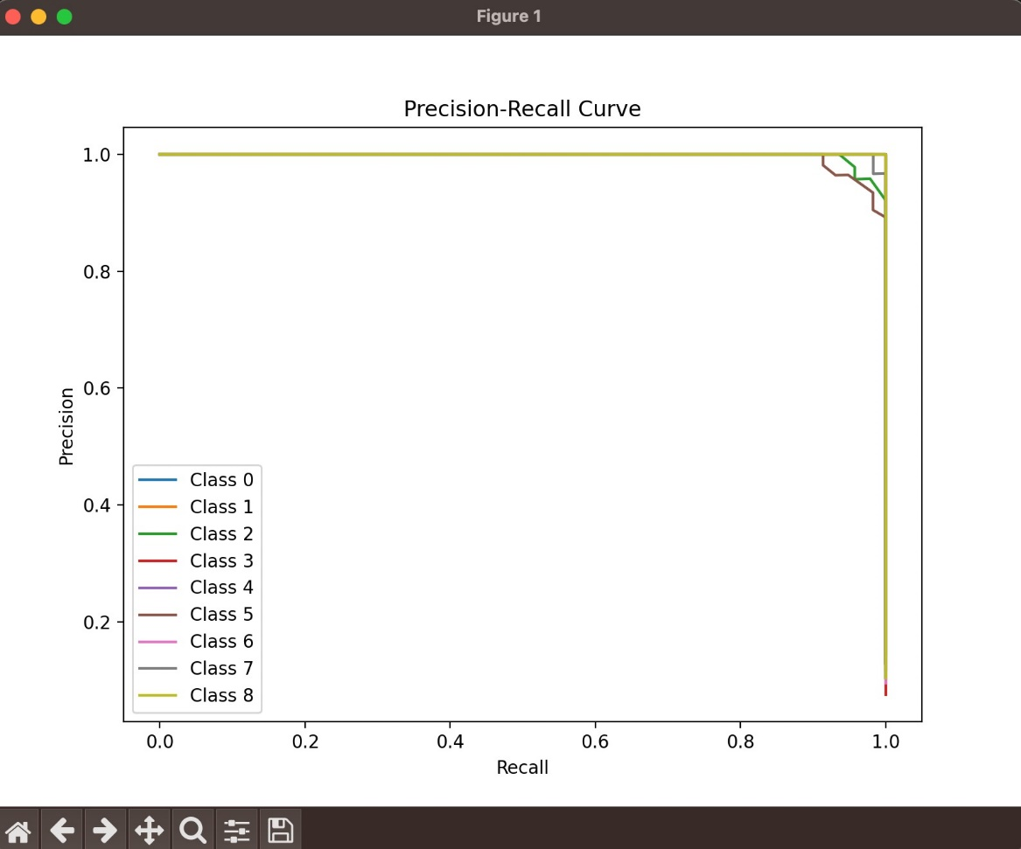

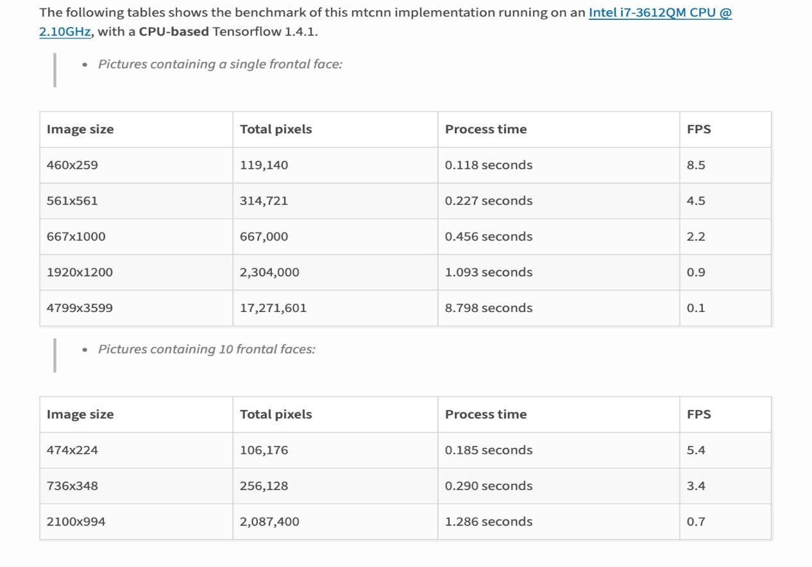
Benchmark of MTCNN implementation

15
CHAPTER 6

Advantages and Disadvantages

•Advantages:
1) Accuracy: Face recognition technology is highly accurate, with the ability to identify individuals with a high degree of precision. This makes it an effective tool for tracking attendance and preventing fraudulent behavior.
2) Speed: Face recognition-based attendance systems can quickly scan and identify individuals, making the process of checking attendance much faster than traditional methods.
3) Cost-effective: Face recognition-based attendance systems can be cost-effective compared to other biometric technologies such as fingerprint or iris recognition. Additionally, they can help reduce costs associated with manual tracking of attendance.
4) Improved security: Face recognition technology provides a high level of security and can help prevent unauthorized access to sensitive areas. This is particularly important in industries where security is a top concern, such as government and finance.

•Disadvantages:
1)Technical limitations: Face recognition technology may not work as well for certain individuals, such as those with facial hair, facial piercings, or certain skin conditions. Additionally, the system may not work well in certain lighting conditions or angles, leading to inaccuracies.
2)Privacy concerns: There are concerns about the collection and storage of biometric data, including facial images. This data could potentially be misused or stolen, leading to privacy violations and identity theft.
3)Security vulnerabilities: Like any technology, face recognition-based attendance systems may be vulnerable to cyber-attacks or hacking, leading to security breaches and data loss.

16

•Applications:

1)Workplace attendance tracking: Facial recognition systems can be used to track employee attendance in the workplace. Employees can simply walk past the camera and the system will automatically record their attendance.

2)School attendance tracking: Similar to workplace attendance tracking, facial recognition systems can be used in schools to monitor attendance. This can help schools ensure that students are attending classes and can help with truancy prevention.

3)Security: Facial recognition systems can be used for security purposes, such as identifying individuals entering a secure facility or preventing unauthorized access to restricted areas.

4)Time and attendance management: Facial recognition systems can be used to manage employee time and attendance, including tracking hours worked, overtime, and vacation time.

5)Access control: Facial recognition systems can be used to control access to buildings, rooms, and other restricted areas. The system can be set up to only allow authorized individuals to enter.

6)Verification of identity: Facial recognition systems can be used to verify the identity of individuals, such as for financial transactions, access to online accounts, and other secure processes.

17

CHAPTER 7

Conclusion

Conclusion

- The project report on "Face Detection and Face Recognition" has provided a comprehensive exploration of ‘Visage AI’ technologies, their methodologies, advancements, challenges, applications, and ethical considerations. Through an extensive review of the literature, we have gained valuable insights into the historical developments and significant contributions in the field.

- The report highlighted the transition from traditional approaches to deep learning-based algorithms, showcasing the remarkable improvements in accuracy and robustness achieved in face detection and recognition. We explored notable techniques such as Viola-Jones, Histogram of Oriented Gradients (HOG), and Convolutional Neural Networks (CNNs), along with their applications and limitations.

- We also discussed the wide-ranging applications of face detection and recognition, including their role in security systems, surveillance, human-computer interaction, social media, and personalized experiences. These technologies have revolutionized various industries, enhancing access control, public safety, and user experiences.

- This report serves as a valuable resource for researchers, engineers, and practitioners, fostering further research and development in this dynamic and rapidly evolving field of ‘Visage AI’. As face detection and recognition continue to advance, it is crucial to ensure their responsible and equitable deployment, keeping ethics and privacy at the forefront.

18

REFERENCES

[1] MIT Open Courseware, "Introduction to Deep Learning," YouTube video, Mar. 6, 2017. [Online]. Available: https://youtu.be/QDX-1M5Nj7s .[Accessed: May 9, 2023].

[2] ML Bootcamp, "Facial Recognition, Mood Detection," YouTube video, live stream, Aug. 25, 2021. [Online]. Available: https://www.youtube.com/live/2BOxO93WMII?feature=share . [Accessed: May 9, 2023].

[3] NVIDIA Corporation, "Session Catalog - GTC Spring 2023," NVIDIA Flow webpage, [Online]. Available: https://register.nvidia.com/flow/nvidia/gtcspring2023/attendeeportal/page/sessioncatalog/session/1666205357204001Efly . [Accessed: May 9, 2023].

[4] NVIDIA Corporation, "Session Catalog - GTC Spring 2023," NVIDIA Flow webpage, Session ID: 1674246903903001yxKR. [Online]. Available: https://register.nvidia.com/flow/nvidia/gtcspring2023/attendeeportal/page/sessioncatalog/session/1674246903903001yxKR . [Accessed: May 9, 2023].

[5] Y. Taigman, M. Yang, M. Ranzato, and L. Wolf, "DeepFace: Closing the Gap to Human-Level Performance in Face Verification," in Proceedings of the IEEE Conference on Computer Vision and Pattern Recognition, 2014, pp. 1701-1708.

[6]W. Liu, D. Anguelov, D. Erhan, C. Szegedy, S. Reed, C.-Y. Fu, and A. C. Berg, "SSD: Single Shot MultiBox Detector," in Proceedings of the European Conference on Computer Vision, 2016, pp. 21-37.

19

